* 1. Practical activity: Measurement stations

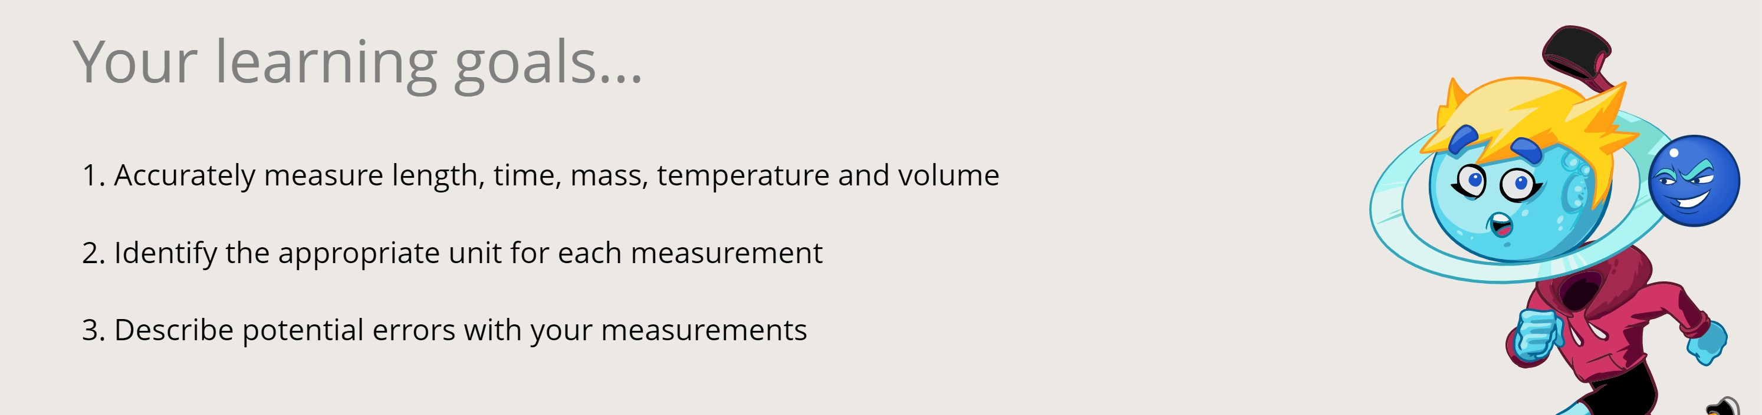

In your scientific investigations, you'll need to be able to make a range of different measurements, such as length, temperature and volume. It's important to use the measuring equipment correctly to get accurate results.

For your measurements to have any meaning, you must write them with the correct **units**. For example, a friend says she'll be at your house in 15. You would hope she meant minutes rather than hours or days!

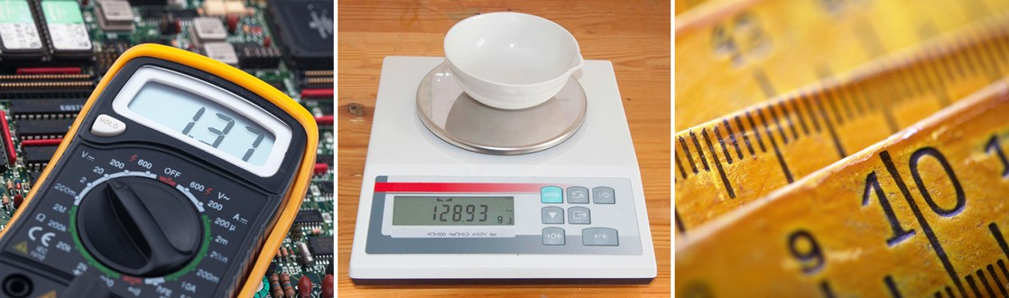

Common measuring equipment: a multimetre for measuring properties of electric circuits (left), an electronic mass balance (centre), and rulers (right).

## Question 1

**Complete** the table by identifying the common units and equipment associated with each type of measurement. Be sure to include an example of something you could measure using this type of measurement.

*Note: An object's "mass" is how much matter it contains. In ordinary life we usually call this the object's "weight".*

|  |  |  |  |
| --- | --- | --- | --- |
| **Measurement** | **Common units** | **Equipment** | **Example** |
| length | centimetre (cm)  kilometre (km) | meter ruler  trundle wheel | measuring the length of your thumb using a 30 cm ruler |
| temperature |  |  | measuring your body temperature when you are sick |
| mass |  | scales  electronic mass balance |  |
| volume (liquids) | mililitre (mL)  litre (L) |  |  |
| time |  |  |  |

## Question 2

You want to measure how long it takes your friend to eat a dry Weetbix.

**Select** the best unit of measurement and piece of equipment to use.

seconds; measuring cylinder hours; stopwatch

minutes; electronic mass balance minutes; stopwatch

I'm not sure

## Question 3

You want to measure the length of a football field.

**Select** the best unit of measurement and piece of equipment to use.

millimetres; tape measure metres; trundle wheel kilograms; trundle wheel metres; 30 cm ruler

I'm not sure

# Aim

To measure length, temperature, mass, volume and time accurately.

# Part 1: Length

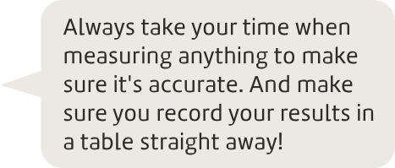Materials you will need:

cotton balls meter ruler

Method:

* + 1. Throw a cotton ball with your right hand.
    2. Measure the distance it travelled.
    3. Throw a cotton ball with your left hand.
    4. Measure the distance it travelled.

## Question 4

**Complete** the table by filling in the distance that the cotton ball travelled when thrown with each hand. Remember to include units!

|  |  |
| --- | --- |
|  | **Distance travelled by the cotton ball** |
| Right hand |  |
| Left hand |  |

# Part 2: Temperature

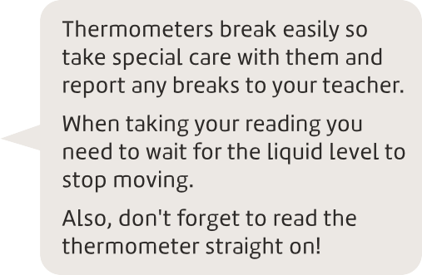Materials you will need:



3 thermometers

100 mL beaker labelled ‘ice’ 100 mL beaker labelled ‘hot’ ice cubes

hot water (your teacher will provide this)

250 mL measuring jug (for transporting hot water)

felt-tip marker

Method:

1. Measure the temperature of the following and record the results in the table below:
   1. the room temperature of the classroom
   2. cold water with ice cubes in it
   3. hot water
   4. your armpit

## Question 5

 **Key Question**

**Complete** the table by filling in the temperatures you measured. Remember to include units.

|  |  |
| --- | --- |
| **Object** | **Temperature** |
| Room temperature |  |
| Ice water |  |
| Hot water |  |
| Body (armpit) temperature |  |

# Part 3: Time

Materials you will need:



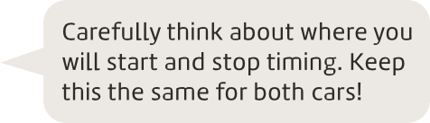2 toy cars ramp stopwatch

Method:

1. Set up a ramp and hold one of the cars at the top.
2. Time how long it takes for the car to roll down the ramp.
3. Repeat with the second car.

## Question 6

**Complete** the table by filling in the time it took for each car to roll down the ramp. Remember to include units.

|  |  |
| --- | --- |
|  | **Time taken** |
| Car 1 |  |
| Car 2 |  |

# Part 4: Mass

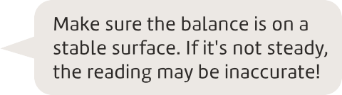Materials you will need:

electronic mass balance selection of toys

Method:

1. Turn on the balance and wait for the screen to read 0.00 g. If it doesn't, press the "zero" or "tare" button.
2. Place one of the toys on the balance and wait for the reading to stop changing.
3. Record the mass of the toy in the table below.
4. Repeat steps 1 to 3 with three other toys.

## Question 7

**Complete** the table by filling in the mass of each object you weighed. Remember to include units.

|  |  |
| --- | --- |
| **Object** | **Mass** |
|  |  |
|  |  |
|  |  |
|  |  |

# Part 5: Volume

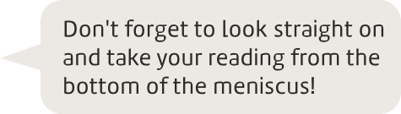Materials you will need:

100 mL beaker

250 mL beaker

100 mL Measuring cylinder 100 mL conical flask

250 mL conical flask water

Method:

1. Without using the measuring cylinder, pour 52 mL of water into the 100 mL beaker. Use the measurement markings on the side of the beaker to guide you.
2. Pour the water from the beaker into the measuring cylinder to see how accurate you were. Record these results in the table below.
3. Repeat steps 1 and 2 with the 100 mL beaker, 50 mL conical flask and 100 mL conical flask.

## Question 8

**Complete** the table by filling in the actual volume of water you poured into each container. Remember to include units.

|  |  |
| --- | --- |
| **Container** | **Volume of water** |
| 100 mL beaker |  |
| 250 mL beaker |  |
| 100 mL conical flask |  |
| 250 mL conical flask |  |

## Question 9

You need to measure exactly 15 mL of water for an investigation. **Explain** whether you should use a beaker, a conical flask or a measuring cylinder and refer to your results in the table above.

## Question 10

 **Key Question**

**Match** the measurement and most appropriate unit to each piece of measuring equipment below. In some cases you may need to estimate. Round the answer to one decimal place.

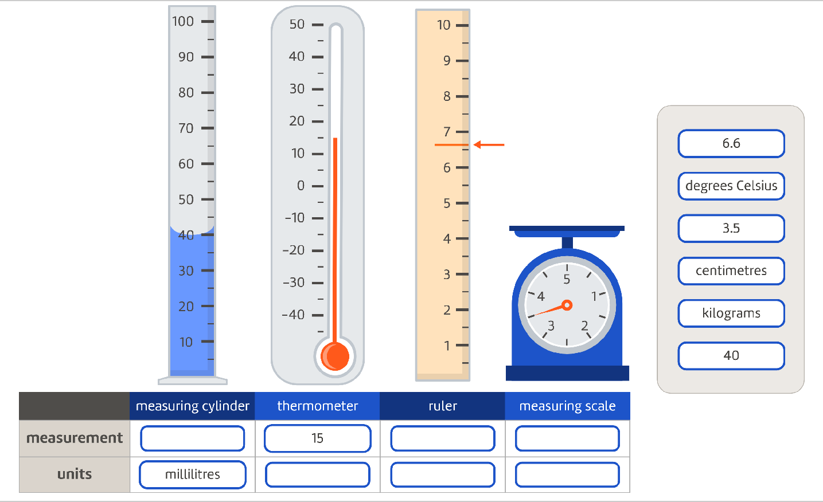

# Reflection

## Question 11

 **Key Question**

Think about all of the measurements you made. **Describe** whether it was difficult to get an accurate reading for any of them. If so, **explain** why it was difficult.

## Question 12

**Determine** what you will do next time to improve the accuracy of your results.

**Credits:** Photos, Adobe Stock.